IBM Assignment – 2

Name: Soundarya S

Roll no: 19BCS023

-----------------------------------------------------------------------------------------------------------------------------------------------------

Here is the final dashboard. And the detailed individual visualizations are attached after this for understanding.

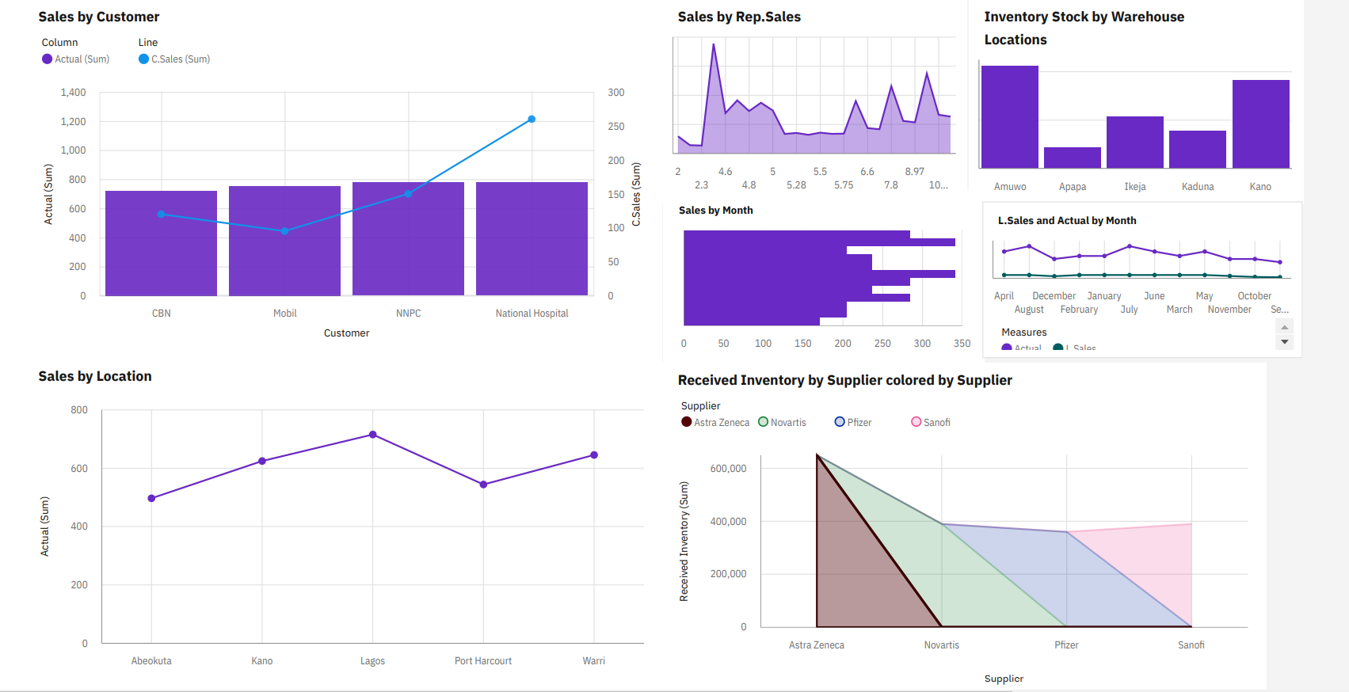

1. Sales by customer

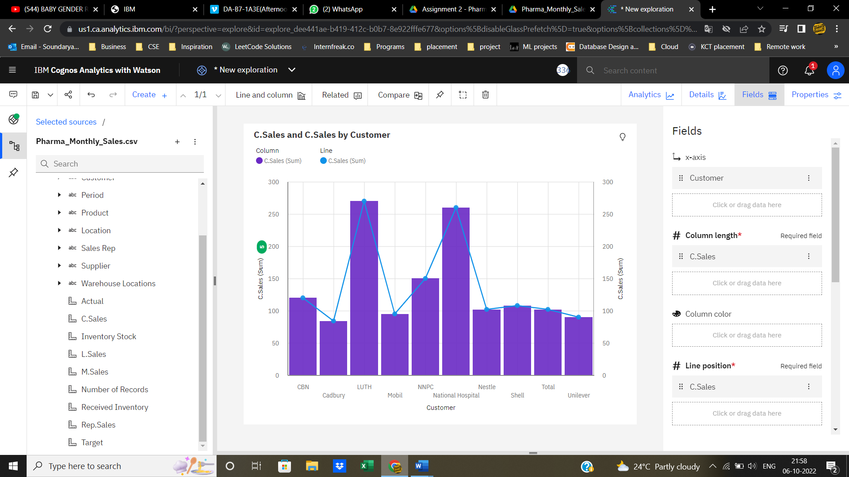

1. Actual Sales by Location

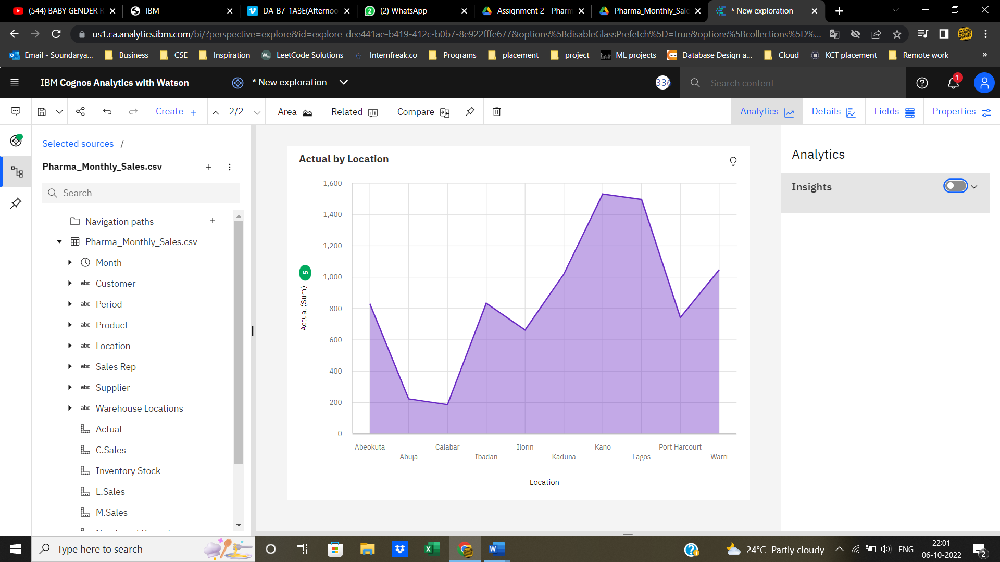

1. Sales by Sales representatives

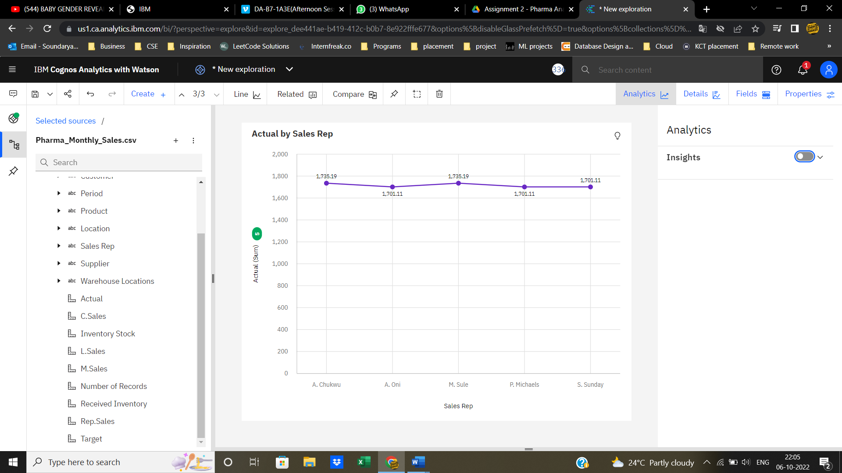

1. Received inventory by supplier

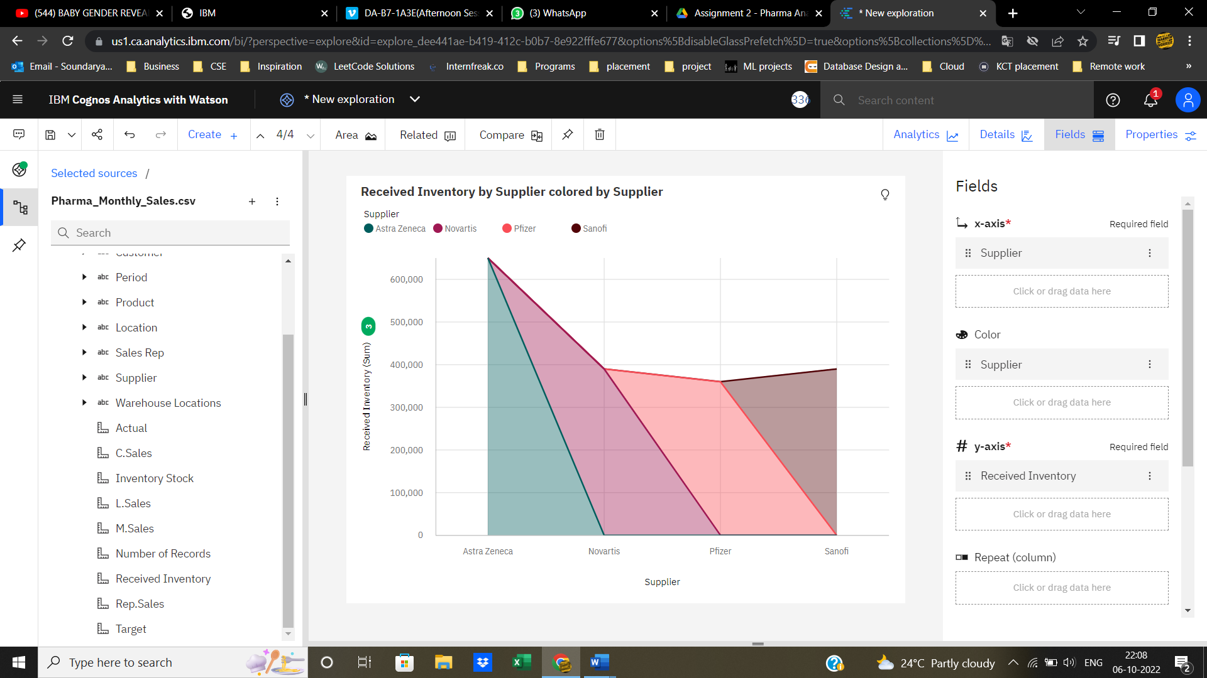

1. Inventory stock by warehouse locations

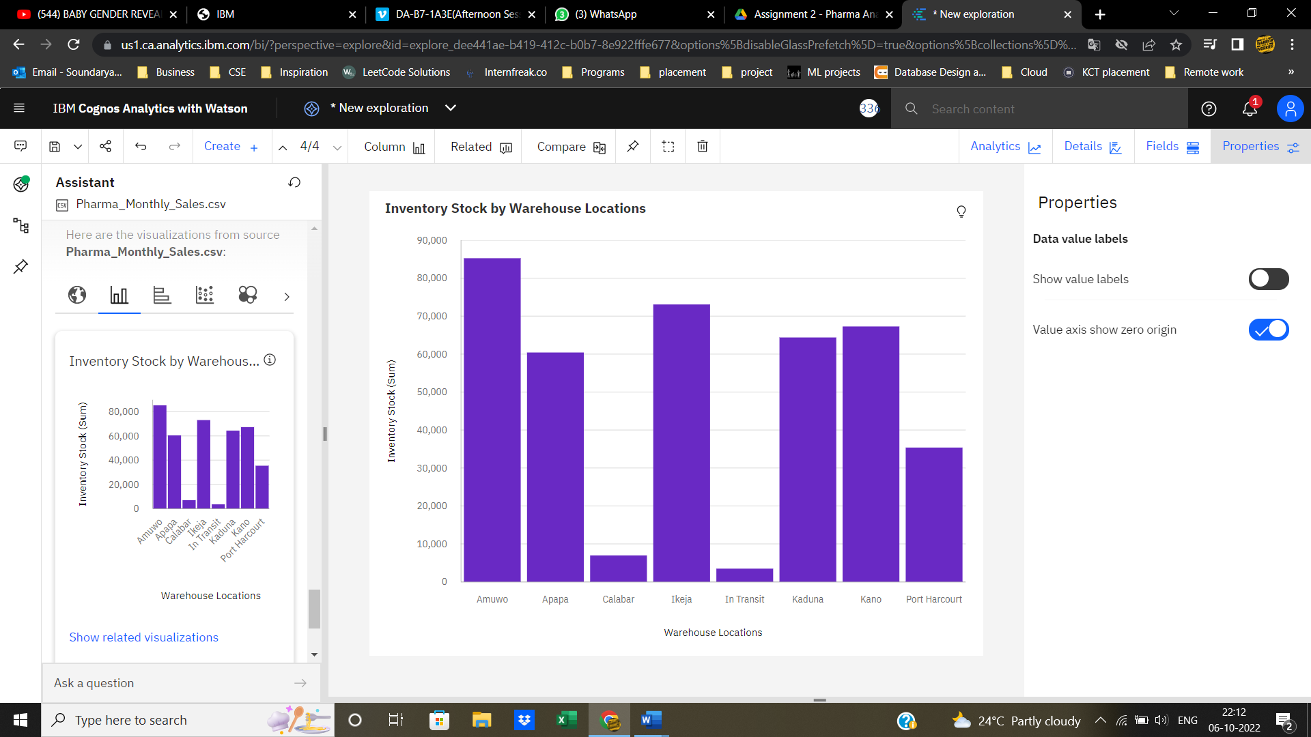

1. Sales trend

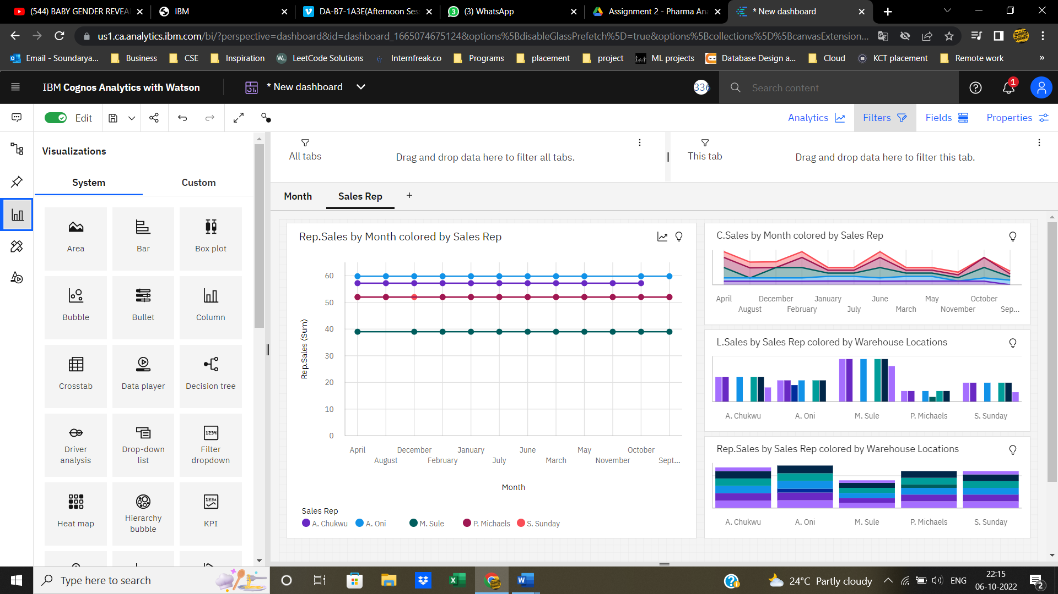

1. Monthly sales

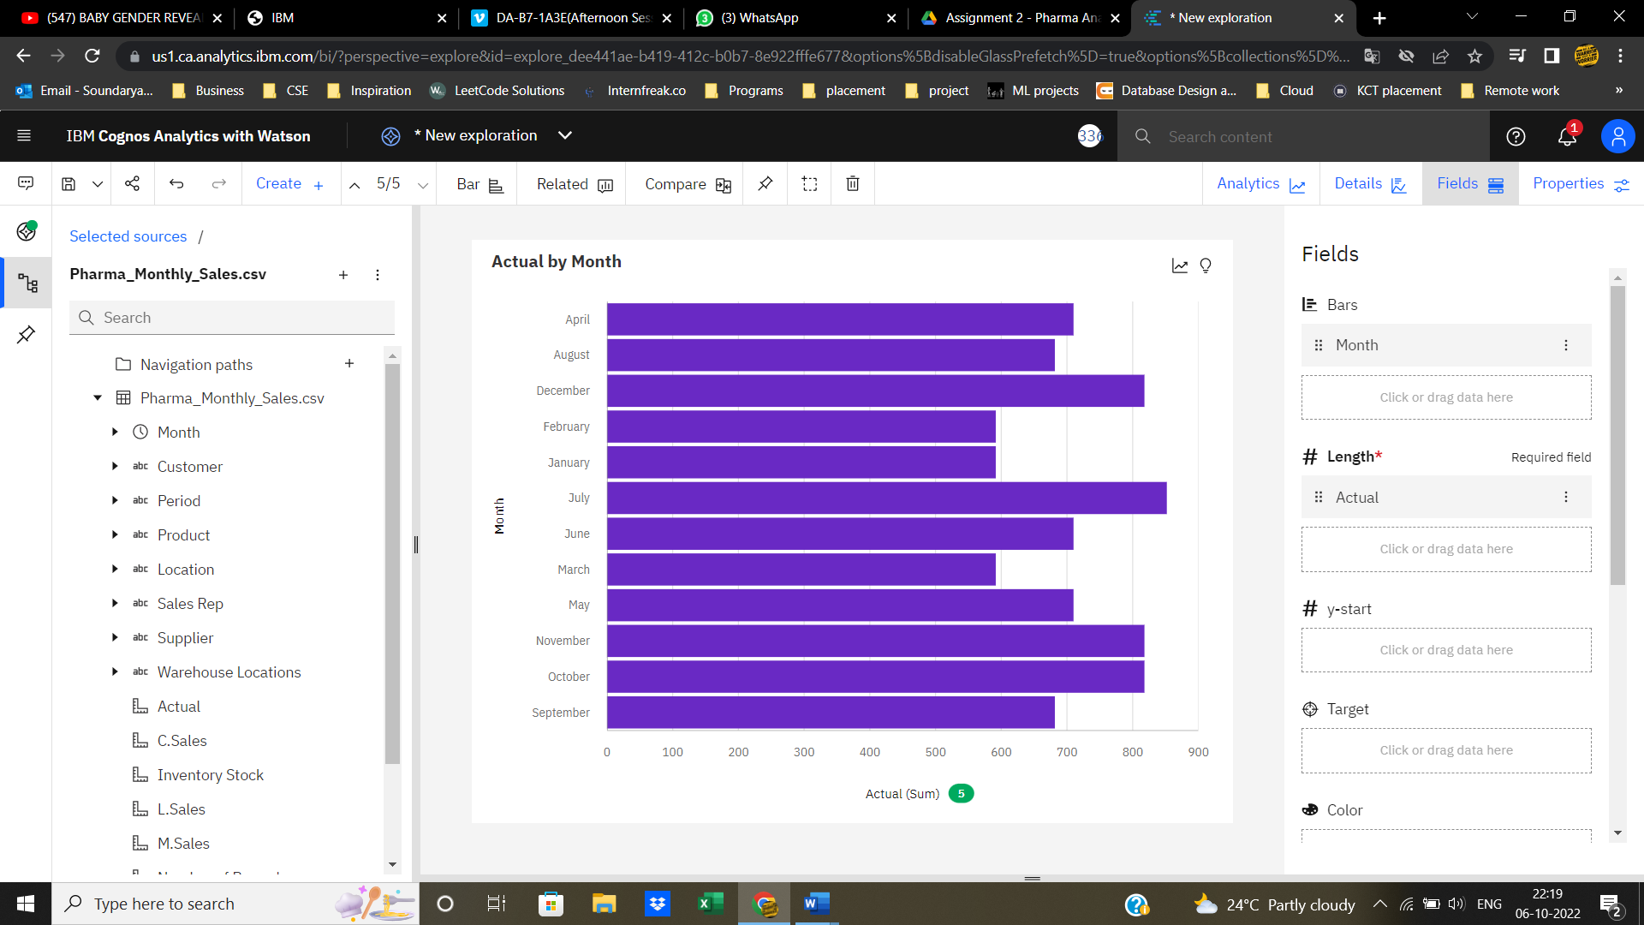

1. Actual and Received inventory by month

